Cloud Computing Project

Final-Term Project Report

Evaluation of cassandra, hbase & rEDIS through ycsb

Redis DHT Implementation

Team Members:

chandani madnani (cxm152930)

Priyanka chadalavada (pxe162330)

raveena singh (rxs159830)

roshan ravikumar (rxr151330)

2016

Table of Contents

Goal of the project: 3

Introduction: 3

YCSB 4

Basic operations: 4

Distributions: 5

Experimental Results – Cassandra, Hbase & Redis 7

YCSB Workloads Run Throughput 7

YCSB Workload Load Throughput 8

Cassandra – 4 nodes vs 8 nodes 9

Workloadb – Thread Count/Throughput Performance Comparison 10

Workloadb – Thread Count/Read Latency Performance Comparison 10

Workloadb – Thread Count/Update Latency Performance Comparison 11

Workloadc – Thread Count/Throughput Performance Comparison 11

Workloadc - Thread Count /Read Latency Performance Comparison 12

Workloada – Thread Count/Throughput Performance Comparison 12

Workloada – Thread Count/Read Latency Performance Comparison 13

Workloada – Thread Count/Update Latency Performance Comparison 13

HBase – Special Scenarios Testing 14

Observation 1 – Time skew larger between Hbase Master and it’s region servers 14

Observation 2 – Cluster Behavior on adding a new Region Server 15

Observation 3 – Cluster Behavior on killing a region server 19

Observation 4 - Killing the Node 21

Observation 5 – Performance Impact of Major Compaction on the Cluster 23

Cassandra – Special Scenarios Testing 25

Observation 1 – Cluster Behavior on replacing a dead node. 25

Observation 2 – Performance Impact of Read Consistency Level 27

Observation 3 – Hotspot Testing 28

Observation 4 - Cluster Behavior on killing a node while running YCSB workloada 29

Observation 5 – Decommisioning a node in Cassandra 30

YCSB Source Code Analysis and Creating unbalanced load. 32

Code Flow 32

Code Flow for Load 32

Code Flow for Read 33

Creating unbalanced workloads for Cassandra using YCSB 33

Creating unbalanced workloads for Hbase using YCSB 34

Difficulties Faced 35

Cassandra 35

Hbase 35

Bridged Network Setup 36

Cassandra Architecture in brief: 37

Hbase Architecture In Brief 42

Redis – YCSB code modifications done to test cluster 48

Redis Cluster Creation 49

Redis Node Addition 51

Redis Node Deletion 51

Redis – DHT Implementation 52

Basic DHT Data Structure 52

Architecture in Brief 52

Implementation Details 52

Workload Distribution: 55

One Drive Link: 56

https://cometmail-my.sharepoint.com/personal/cxm152930_utdallas_edu/_layouts/15/guestaccess.aspx?guestaccesstoken=zMO1IXf%2fKuhWlw1qxVF9dsgwSdw9maT90uq4PHwsJEQ%3d&folderid=2_1382254ec285646bfb85c1853298da1f6&rev=1 56

References: 56

# Goal of the project:

Getting hands-on setting up servers/VM on KVM over Centos. Also, compare standard NoSQL databases like Cassandra, Hbase & Redis by using the benchmarking tool YCSB, where we vary parameters and test the servers’ response to different workload distributions and study the performance of these NoSQL databases through experimental analysis. Other goal of the project is to implement the Redis DHT and test it via the Control Client and the Regular Client.

# Introduction:

We started with installation of CentOS followed by installation of KVM on CentOS. We have created all virtual machines on KVM. For Cassandra we have created 8 nodes in the cluster.

As part of Hadoop architecture we have created one VM for namenode and six VMs for datanodes, and for Hbase we have one VM for master and rest 6 VMs for regionservers. The regionserver are on the same node as datanodes.

For Redis, we have a cluster of 6 nodes. 3 Master and 3 Slaves.

We have used qemu qcow2 format for the VM virtual disk.

We have run the benchmark tool on Hbase, Cassandra and Redis using YCSB Tool. We have varied the workloads’ parameters and evaluated the performance of these NoSQL databases.

As part of the implementation of Redis DHT, a control client is implemented to test add node, delete node, add slots, delete slots and load balancing. A regular client is implemented to perform local lookup and remote lookup read requests.

 

# YCSB

We have used a core set of workloads to evaluate the performance of systems, provided by YCSB. Each workload represents a particular mix of read/write/update/scan operations which can be used to evaluate performance of databases depending on the load provided.

## Basic operations:

Each operation against the data store is randomly chosen to be one of:

* Insert: Insert a new record.
* Update: Update a record by replacing the value of one field.
* Read: Read a record, either one randomly chosen field or all fields.
* Scan: Scan records in order, starting at a randomly chosen record key. The number of records to scan is randomly chosen.

## Distributions:

While providing the load, we keep in mind the distribution of the data across the workload. YCSB has provided the following types of distributions:

* *Uniform*: Choose an item uniformly at random. For ex- ample, when choosing a record, all records in the database are equally likely to be chosen.
* *Zipfian*: Choose an item according to the Zipfian distribution. For example, when choosing a record, some records will be extremely popular (the head of the distribution) while most records will be unpopular (the tail).
* *Latest*: Like the Zipfian distribution, except that the most recently inserted records are in the head of the distribution.
* *Multinomial*: Probabilities for each item can be specified

Databases are evaluated on how fast they perform when a particular set of operations are performed on it for a particular dataset. The workloads we’ve used are:

1. **Workload A: Update heavy workload**

This workload has a mix of 50/50 reads and writes. An application example is a session store recording recent actions.

1. **Workload B: Read mostly workload**

This workload has a 95/5 reads/write mix. Application example: photo tagging; add a tag is an update, but most operations are to read tags.

1. **Workload C: Read only**

This workload is 100% read. Application example: user profile cache, where profiles are constructed elsewhere (e.g., Hadoop).

1. **Workload F: Read-modify-write**

In this workload, the client will read a record, modify it, and write back the changes. Application example: user database, where user records are read and modified by the user or to record user activity.

1. **Workload D: Read latest workload**

In this workload, new records are inserted, and the most recently inserted records are the most popular. Application example: user status updates; people want to read the latest.

1. **Workload E: Short ranges**

In this workload, short ranges of records are queried, instead of individual records. Application example: threaded conversations, where each scan is for the posts in a given thread (assumed to be clustered by thread id).

For benchmarking NoSQL databases, we followed the steps below: -

1. We first setup the database and load it with data.
2. Then we chose the workload to test on.
3. Define parameter file and workload
4. Set the preferred runtime parameters.

Sample Command for YCSB

./bin/ycsb load cassandra-cql -threads 32 -p hosts="10.176.128.113,10.176.128.102,10.176.128.132,10.176.128.123,10.176.128.114,10.176.128.103,10.176.128.133,10.176.128.124" -p measurementtype=timeseries -p timeseries.granularity=2000 -P workloads/workloada -s > metrics/cassandra8_workloada_load.txt

Here ***threads*** (32) parameter is used to set the number of parallel threads running. This was done to increase the amount of load offered against the database.

Next ***status*** (-s) is used to get the status of the execution every 10 seconds. It’s helpful for huge workloads to ensure that our system has not crashed and gives some idea about the progress.

**Measurement type** gives throughput periodically. This period can be defined used the **granularity** field.

# Experimental Results – Cassandra, Hbase & Redis

## YCSB Workloads Run Throughput

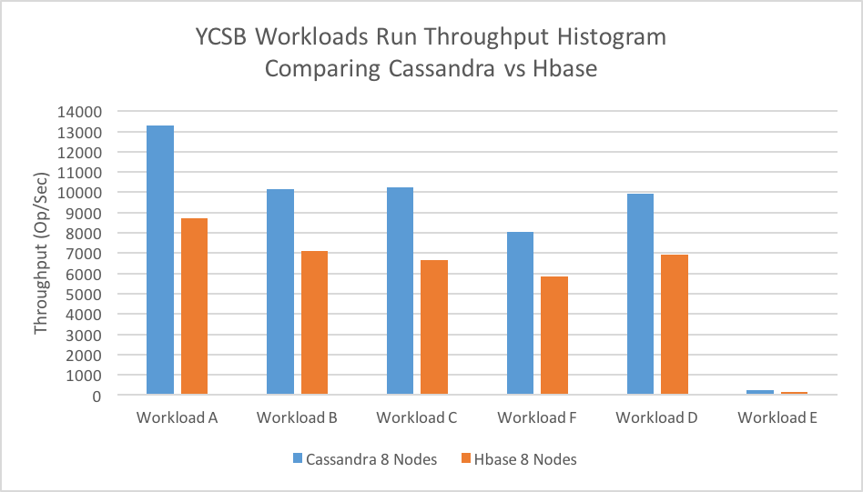

For the given cluster configuration, Cassandra shows higher throughput than HBase both for running the operations of different workloads.

## YCSB Workload Load Throughput

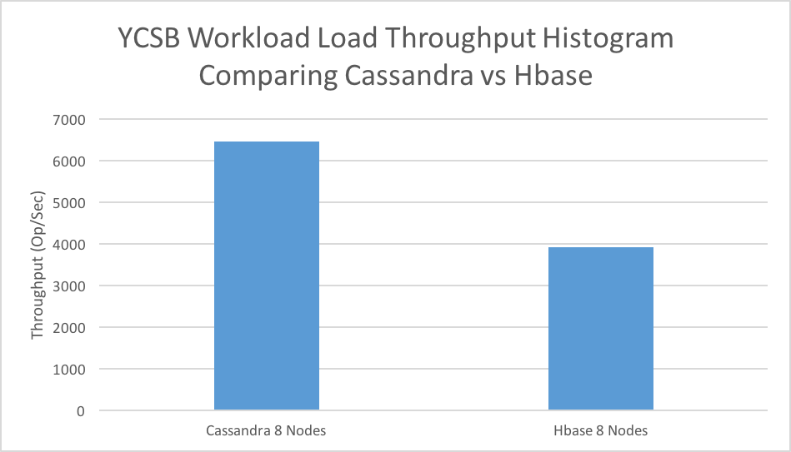

For the given cluster configuration, Cassandra shows higher throughput than HBase both for initial loading of the workload.

## Cassandra – 4 nodes vs 8 nodes

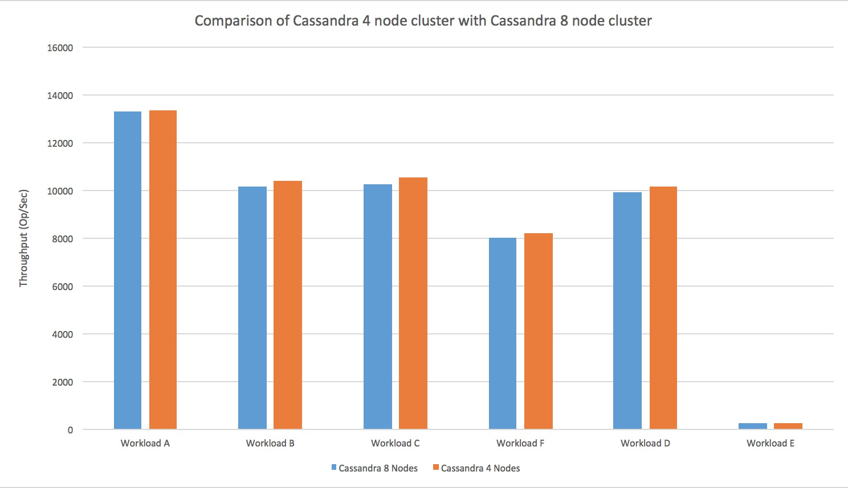

Comparison of Cassandra on 4 nodes and 8 nodes show that the performance is almost the same even after increasing the nodes. This is because two VMs are running on the same physical machine and hence the resources are being shared. Had the 8 nodes been on different physical machines, the performance would have been definitely better.

## Workloadb – Thread Count/Throughput Performance Comparison

## Workloadb – Thread Count/Read Latency Performance Comparison

## Workloadb – Thread Count/Update Latency Performance Comparison

## 

## Workloadc – Thread Count/Throughput Performance Comparison

## Workloadc - Thread Count /Read Latency Performance Comparison

## Workloada – Thread Count/Throughput Performance Comparison

## Workloada – Thread Count/Read Latency Performance Comparison

## Workloada – Thread Count/Update Latency Performance Comparison

## HBase – Special Scenarios Testing

### Observation 1 – Time skew larger between Hbase Master and it’s region servers

The time skew between the HBase master and some of its region servers was larger than the permitted amount due to some reason. HBase refused to start because of this issue.



On analyzing this issue, we found out that the documentation recommends HBase nodes run NTP Service.

**NTP**

The clocks on cluster nodes should be synchronized. A small amount of variation is acceptable, but larger amounts of skew can cause erratic and unexpected behavior. Time synchronization is one of the first things to check if you see unexplained problems in your cluster. It is recommended that you run a Network Time Protocol (NTP) service, or another time-synchronization mechanism, on your cluster, and that all nodes look to the same service for time synchronization. See the Basic NTP Configuration at The Linux Documentation Project (TLDP) to set up NTP.

On installing NTP this issue was resolved.

### Observation 2 – Cluster Behavior on adding a new Region Server

Initially there were 6 regionservers serving 63 regions in total. A new regionserver was started up named datanode7. HBase automatically ran the balancer and some of the regions in the old regionservers were closed and assigned to the new regionserver.

**Initial State after adding Regionserver**

The new regionserver has no regions assigned to it.

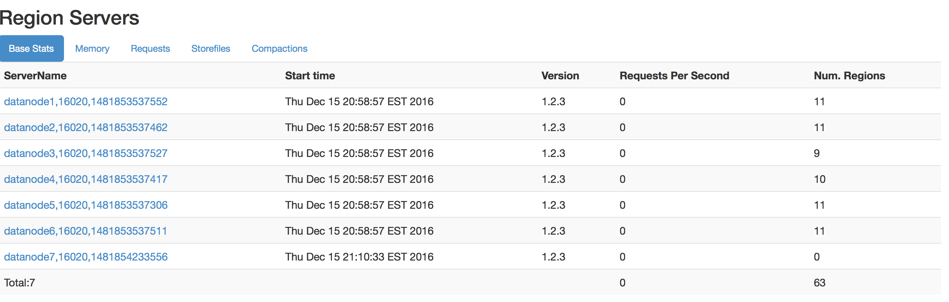

**HBase Balancer Running**

After 4mins the Hbase balancer started running and the regions were moved to the new regionserver from the existing ones.

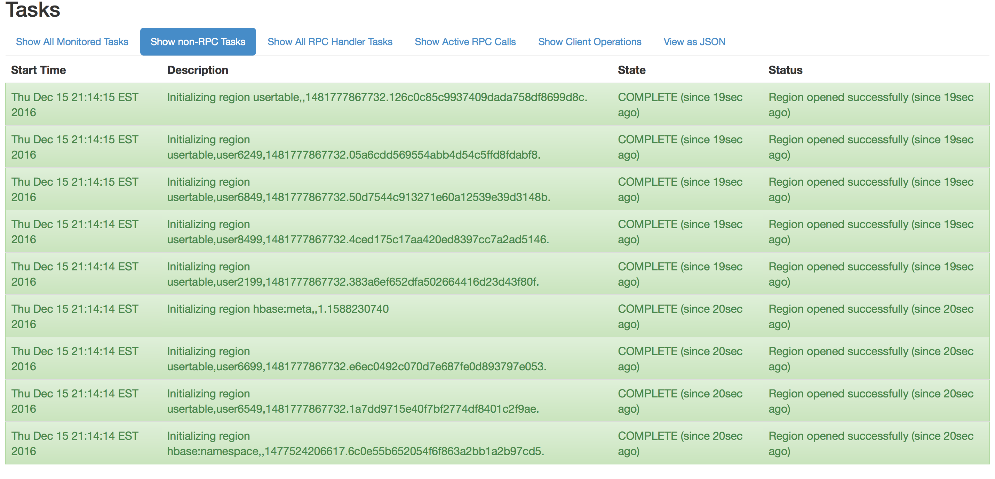

**After Balancer Completed**

Datanode 7 now has 9 regions assigned to it.

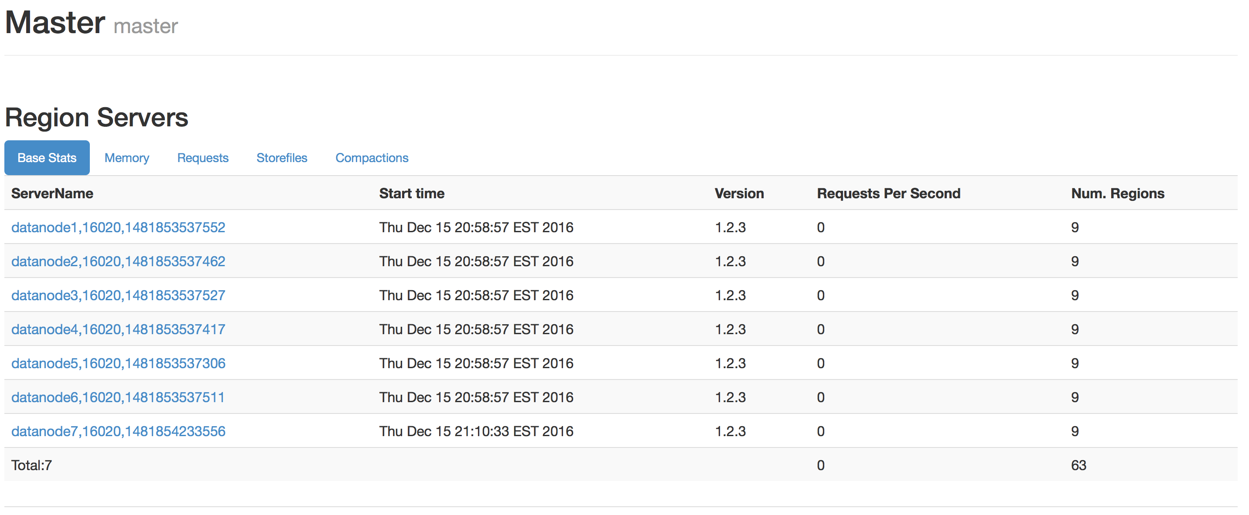

**No Data Locality after HBase balancer**

Even though regions were assigned to the new regionserver, at the HDFS layer no data was moved to the Hadoop datanode running on the newly added node.

Performance of Hbase heavily depends on one of the copies of the region being present in the same machine as the regionserver serving the region.

**Datanode 7 has no data**

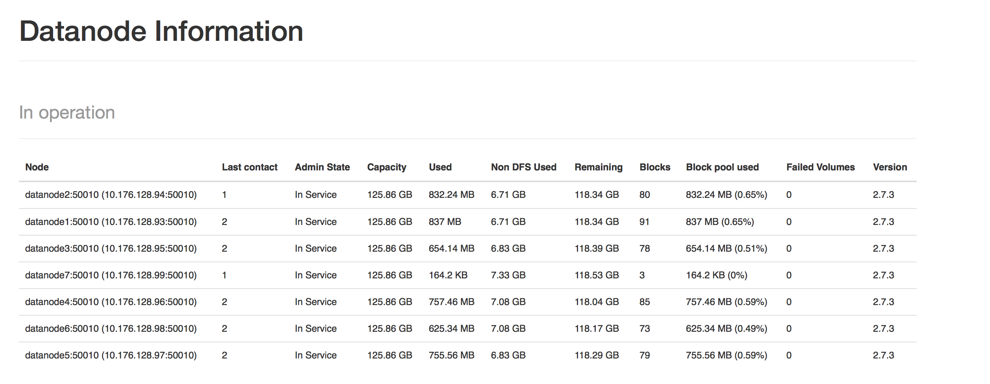

To perform load balancing and moving data to the Hadoop datanode running on the newly added node, we need to run a major compaction.

**Major Compaction**

A major compaction ensures that all data that is owned by a region server is local to that server. It ensures that every regionserver has a 100% data locality (At least one copy present in the same machine).

**Progress of Major Compaction**

Compaction has started and data is being made local to the regionserver serving a region.

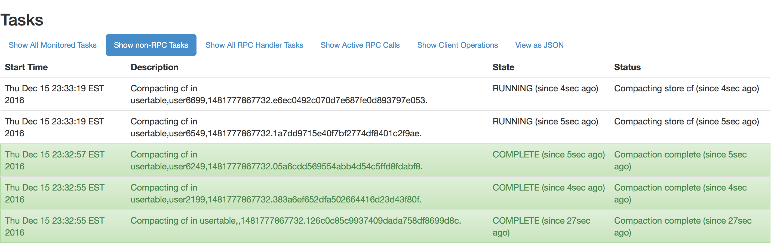

**The Hadoop datanode is now getting some data local to it.**

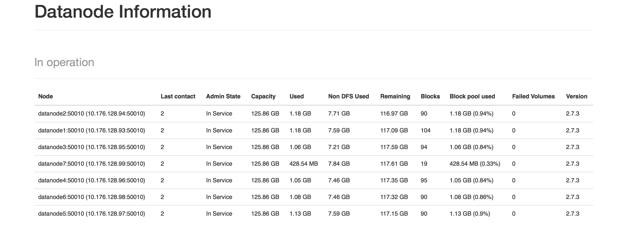

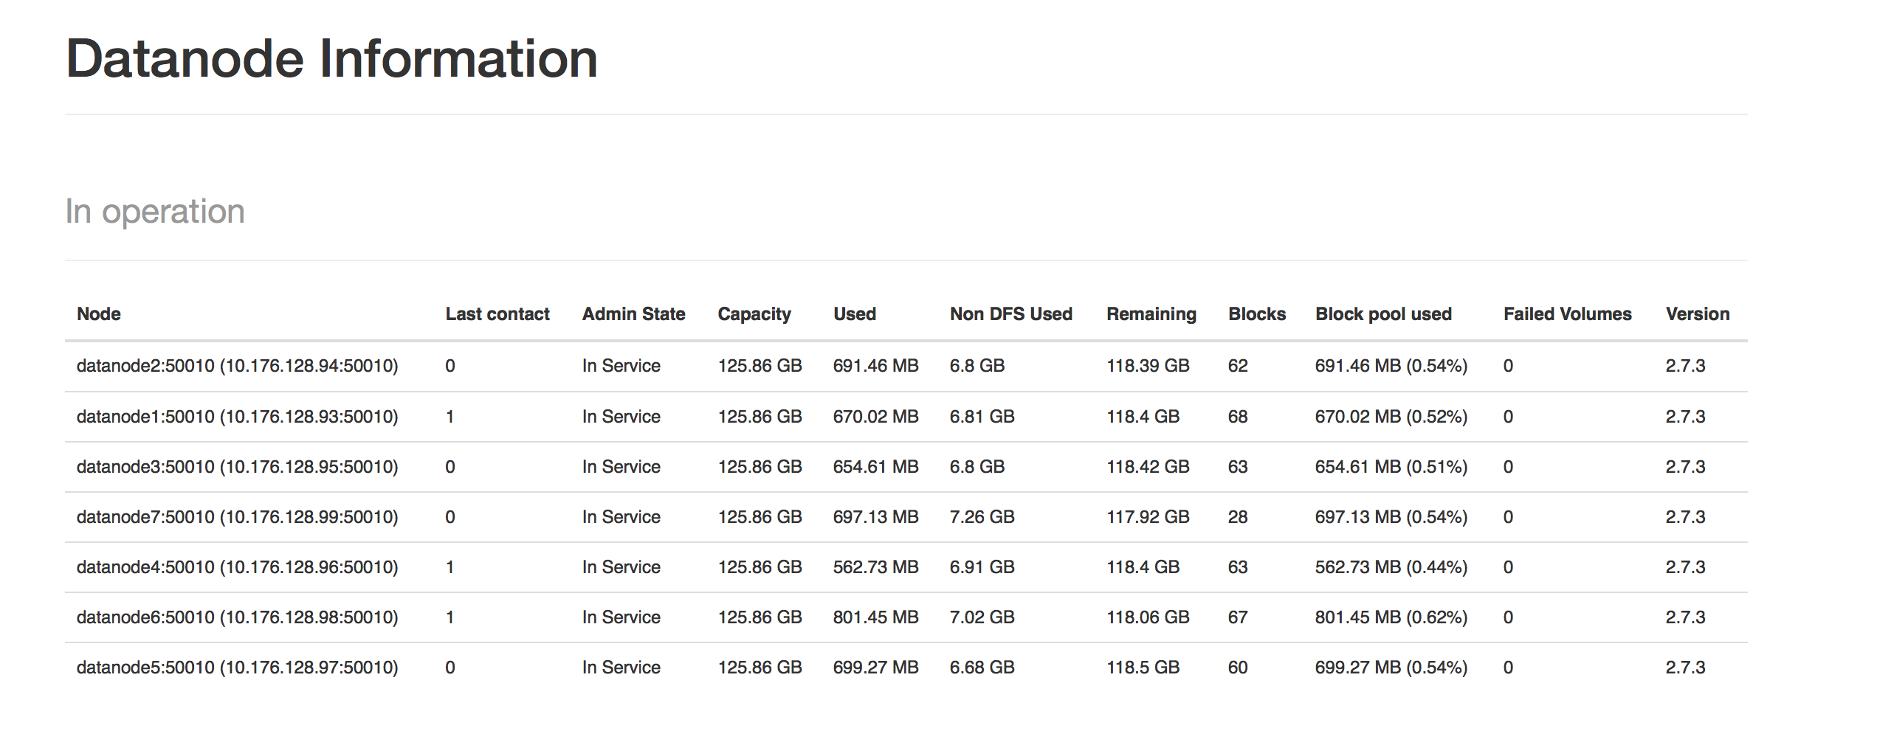

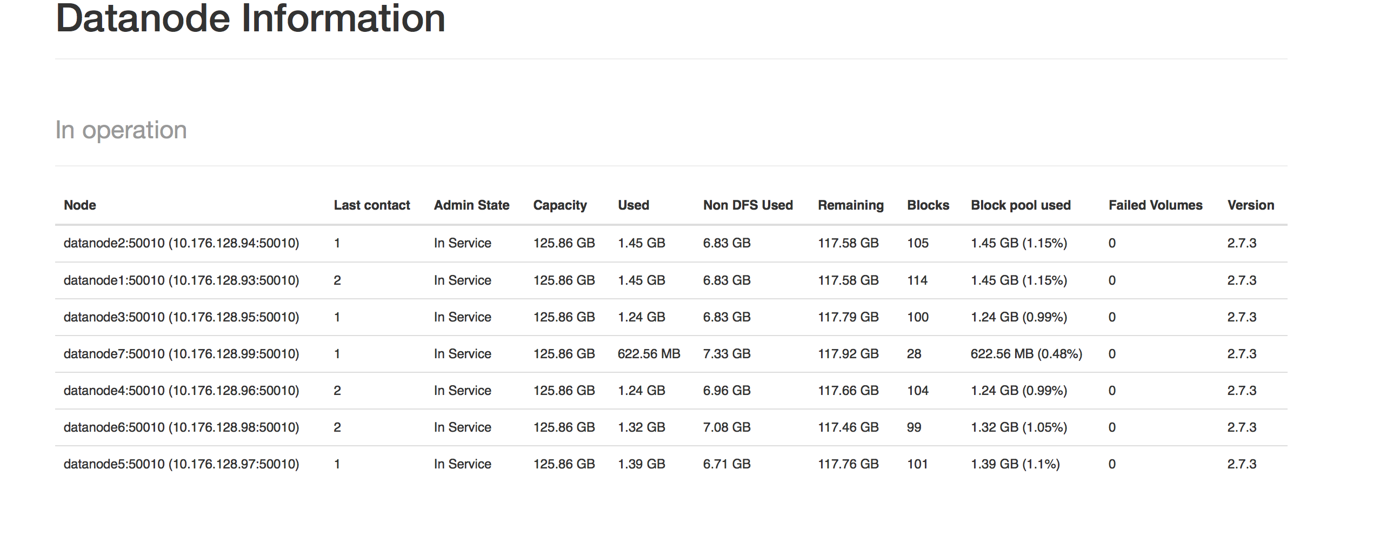

### Observation 3 – Cluster Behavior on killing a region server

Major compaction was run to ensure that all nodes have 100% data locality. This was done to make testing simpler and not have any external factors influence the results.

Continuing from the previous experiment, we had 7 regionservers running and had 100% data locality.

We start running YCSB workloadb, which has a 95/5 reads/write mix. Application example: photo tagging; add a tag is an update, but most operations are to read tags.

While this workload is running, we bring down one the regionservers by exexcuting the following command:

./hbase-daemon.sh stop regionserver

The below image shows datanode7 being down.

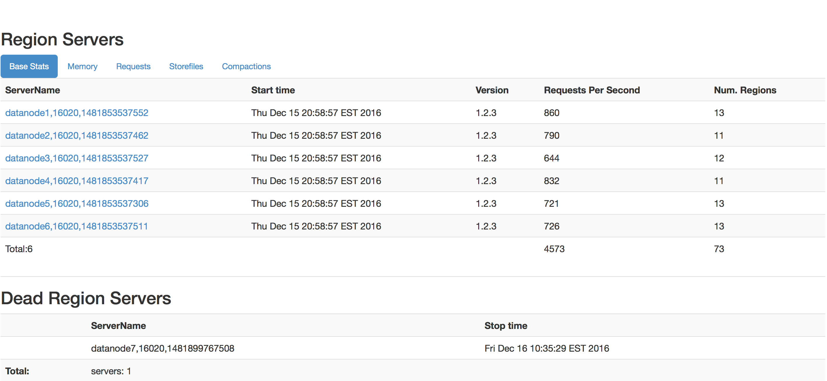

One killing one regionserver, the regions it held are moved to other regionservers. But the data is still present in the old node, since the Hadoop datanode is still running. We only killed the regionserver.

Therefore, the data remains in the old node, but the regions are moved to other nodes. Hence the other regionservers lose their 100% data locality. If we don’t have data locality, the data must be streamed over the network and this reduces the Clusters’ throughput and increase its latency.

The regionserver was killed 130 seconds into the YCSB run. From the diagram below one can immediately notice the drop-in throughput and increase in latency. We think that this is due to the nodes losing data locality and having to stream data over the network for serving read and update requests of workloadb.

**Decreased Throughput**

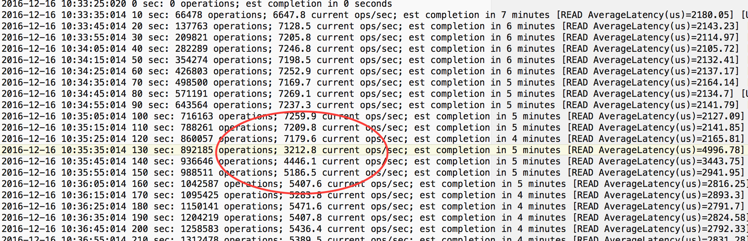

**Increased Latency**

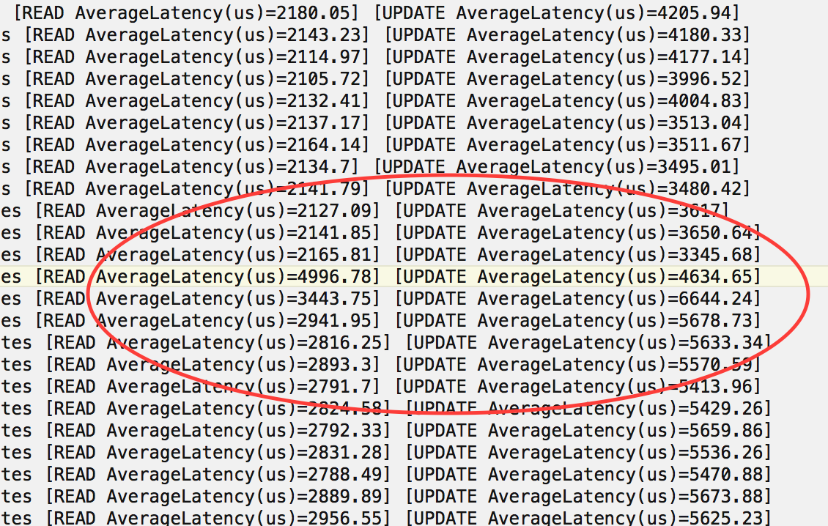

### Observation 4 - Killing the Node

Major compaction was run to ensure that all nodes have 100% data locality. This was done to make testing simpler and not have any external factors influence the results.

Continuing from the previous experiment, we had 7 regionservers running and had 100% data locality.

We start running YCSB workloadb, which has a 95/5 reads/write mix. Application example: photo tagging; add a tag is an update, but most operations are to read tags.

While this workload is running, we bring down the whole node by exexcuting the following command:

virsh shutdown <datanode7>

On killing this node, we see way bigger dip in performance compared the case where we just killed the regionserver process one.

One researching online we found out that this is because of the following fact:

<http://hortonworks.com/blog/introduction-to-hbase-mean-time-to-recover-mttr/>

“The difficulty arises when it’s not a simple process crash, but a node failure. The region server on the crashed node would have written the blocks locally on to the local DataNode (the standard HDFS client behavior). Assuming a replication factor of three, when a box is lost, you are losing not only a region server, but as well one of the three replicas. Doing the split means reading the block. As 33% of the replicas are dead, it means that for each block you’ve got 33% chance to be directed to the wrong replica. Moreover, the split process writes new files. Each of these files will be replicated 3 times: any of these replicas can be assigned to the dead datanode: the write will fail after a timeout, and will go to another datanode, slowing the recovery.”

The node was shutdown 130 seconds into the YCSB workload run.

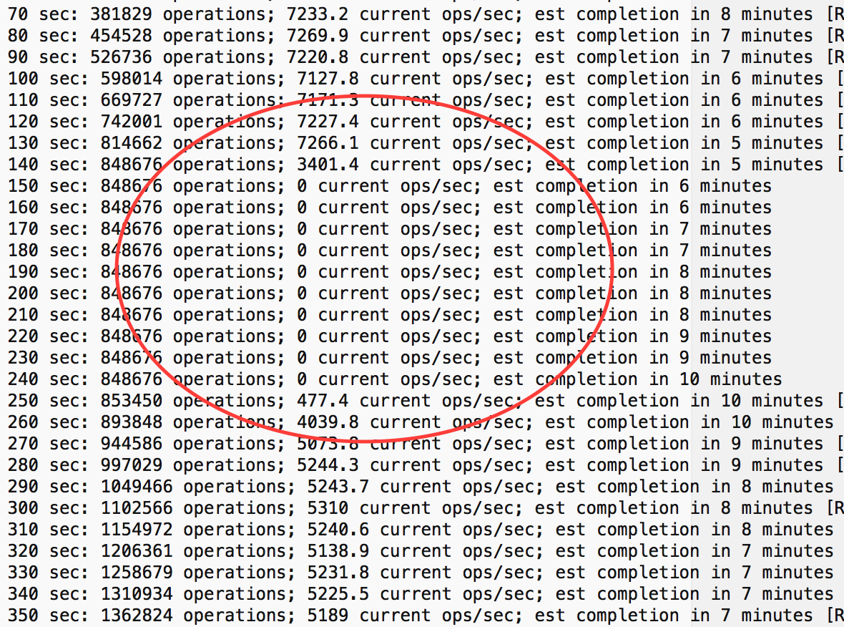

One can observe that the throughput has reduced from 7000 op/sec to around 5000 op/sec.

### Observation 5 – Performance Impact of Major Compaction on the Cluster

In this case, we wanted to run a YCSB workload while a Major compaction was in-progress the cluster.

Some regionservers were killed and brought back up to move regions around and reduce the data locality in the cluster. Now a Major compaction was run.

This had severe impact in the cluster and the performance was dismal.

The image below shows the performance improving once the Major compaction was completed in the cluster.

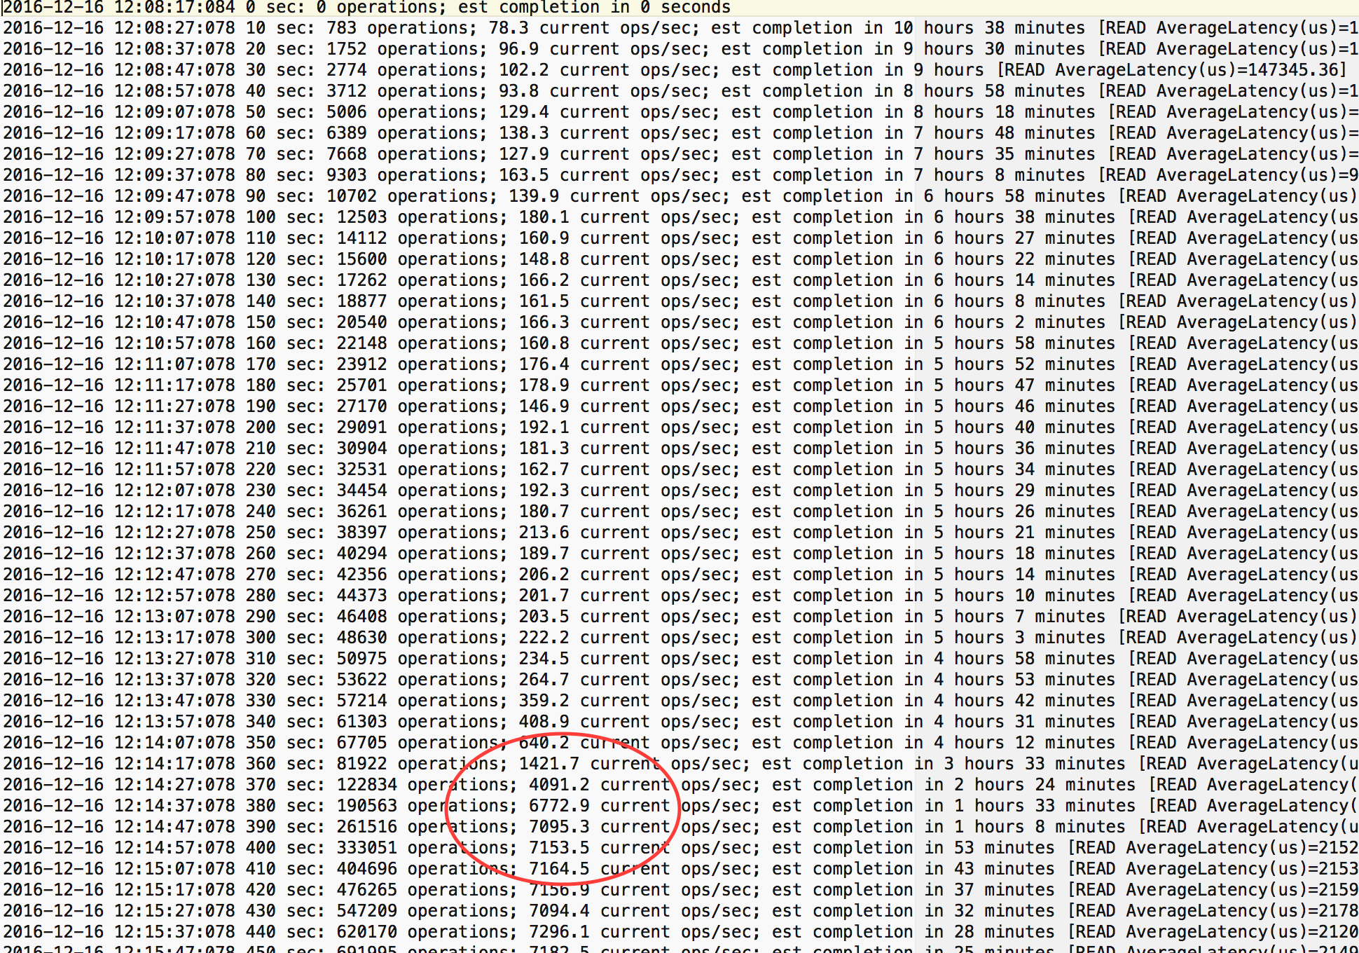

**Table Showing the Metrics comparison for various cases simulated.**

|  |  |  |  |
| --- | --- | --- | --- |
| Case | Throughput (op/sec) | Average Read Latency (us) | Average Update Latency (us) |
| Normal | 6796.186 | 2269.7816 | 3703.8191 |
| Killing Region Server | 5675.7554 | 2684.8233 | 5092.2779 |
| Killing Node | 4470.1394 | 3412.6121 | 5845.1932 |
| Major Compaction | 3893.6564 | 3880.3511 | 8236.1431 |

## Cassandra – Special Scenarios Testing

### Observation 1 – Cluster Behavior on replacing a dead node.

### 

For this test case Cassandra was loaded with 1 Million records using YCSB. After loading one of the nodes was brought down. The replication factor was 3.

A new Cassandra node was created and its function was to be the replacement for the dead node. For this new node, the data will stream from the remaining replicas in the cluster.

The command to start a node as a replacement is show below:

sudo bin/cassandra -Dcassandra.replace_address=address_of_dead_node

In the screenshot below the node 10.176.128.123 is going to be shut down and replaced by a new node 10.176.128.115.

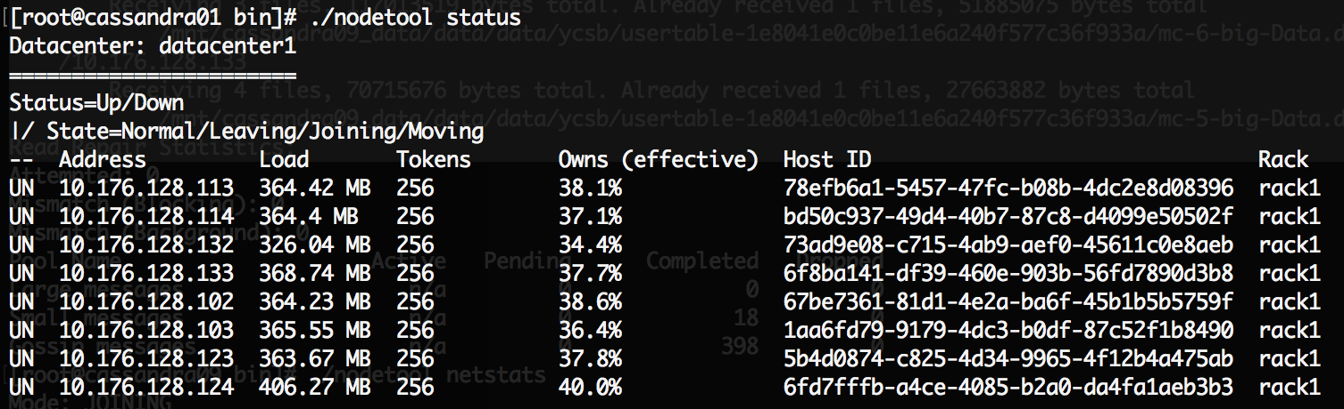

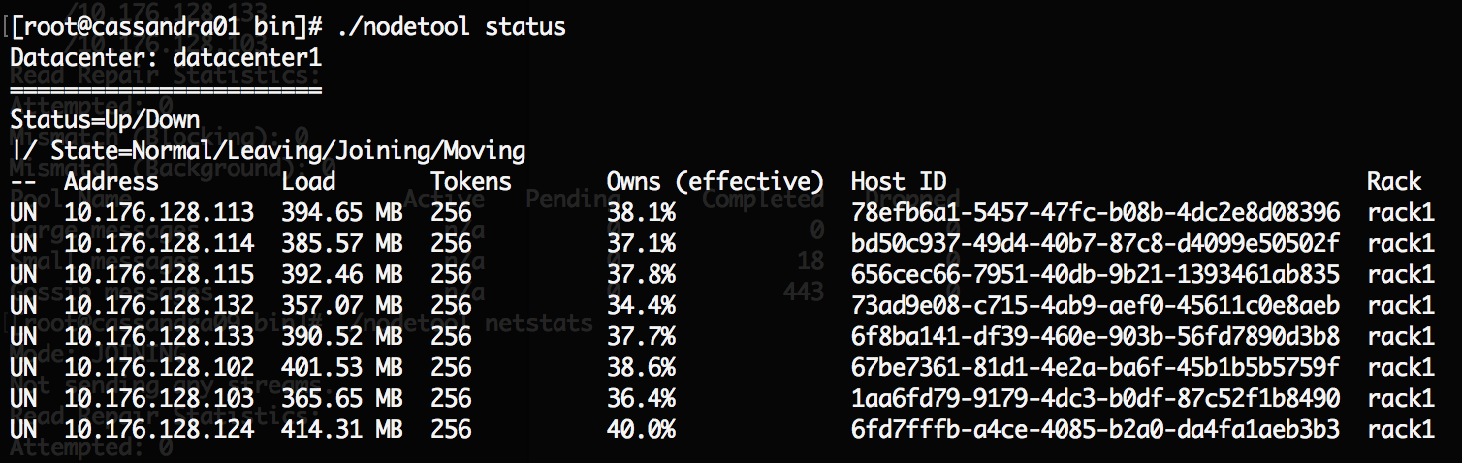

Once the replacement node starts up, it begins the bootstrapping process and begins receiving keys held by 10.176.128.123 from the replicas in the cluster. Ownership changes from the old node to the new node.

The screenshots and logs shown below account this process:

**Sample console output**

WARN 00:21:28 Token -5056327819504790348 changing ownership from /10.176.128.123 to /10.176.128.115

WARN 00:21:28 Token -7127342796749960557 changing ownership from /10.176.128.123 to /10.176.128.115

WARN 00:21:28 Token 8731417198931612467 changing ownership from /10.176.128.123 to /10.176.128.115

**Bootstrapping in Progress**

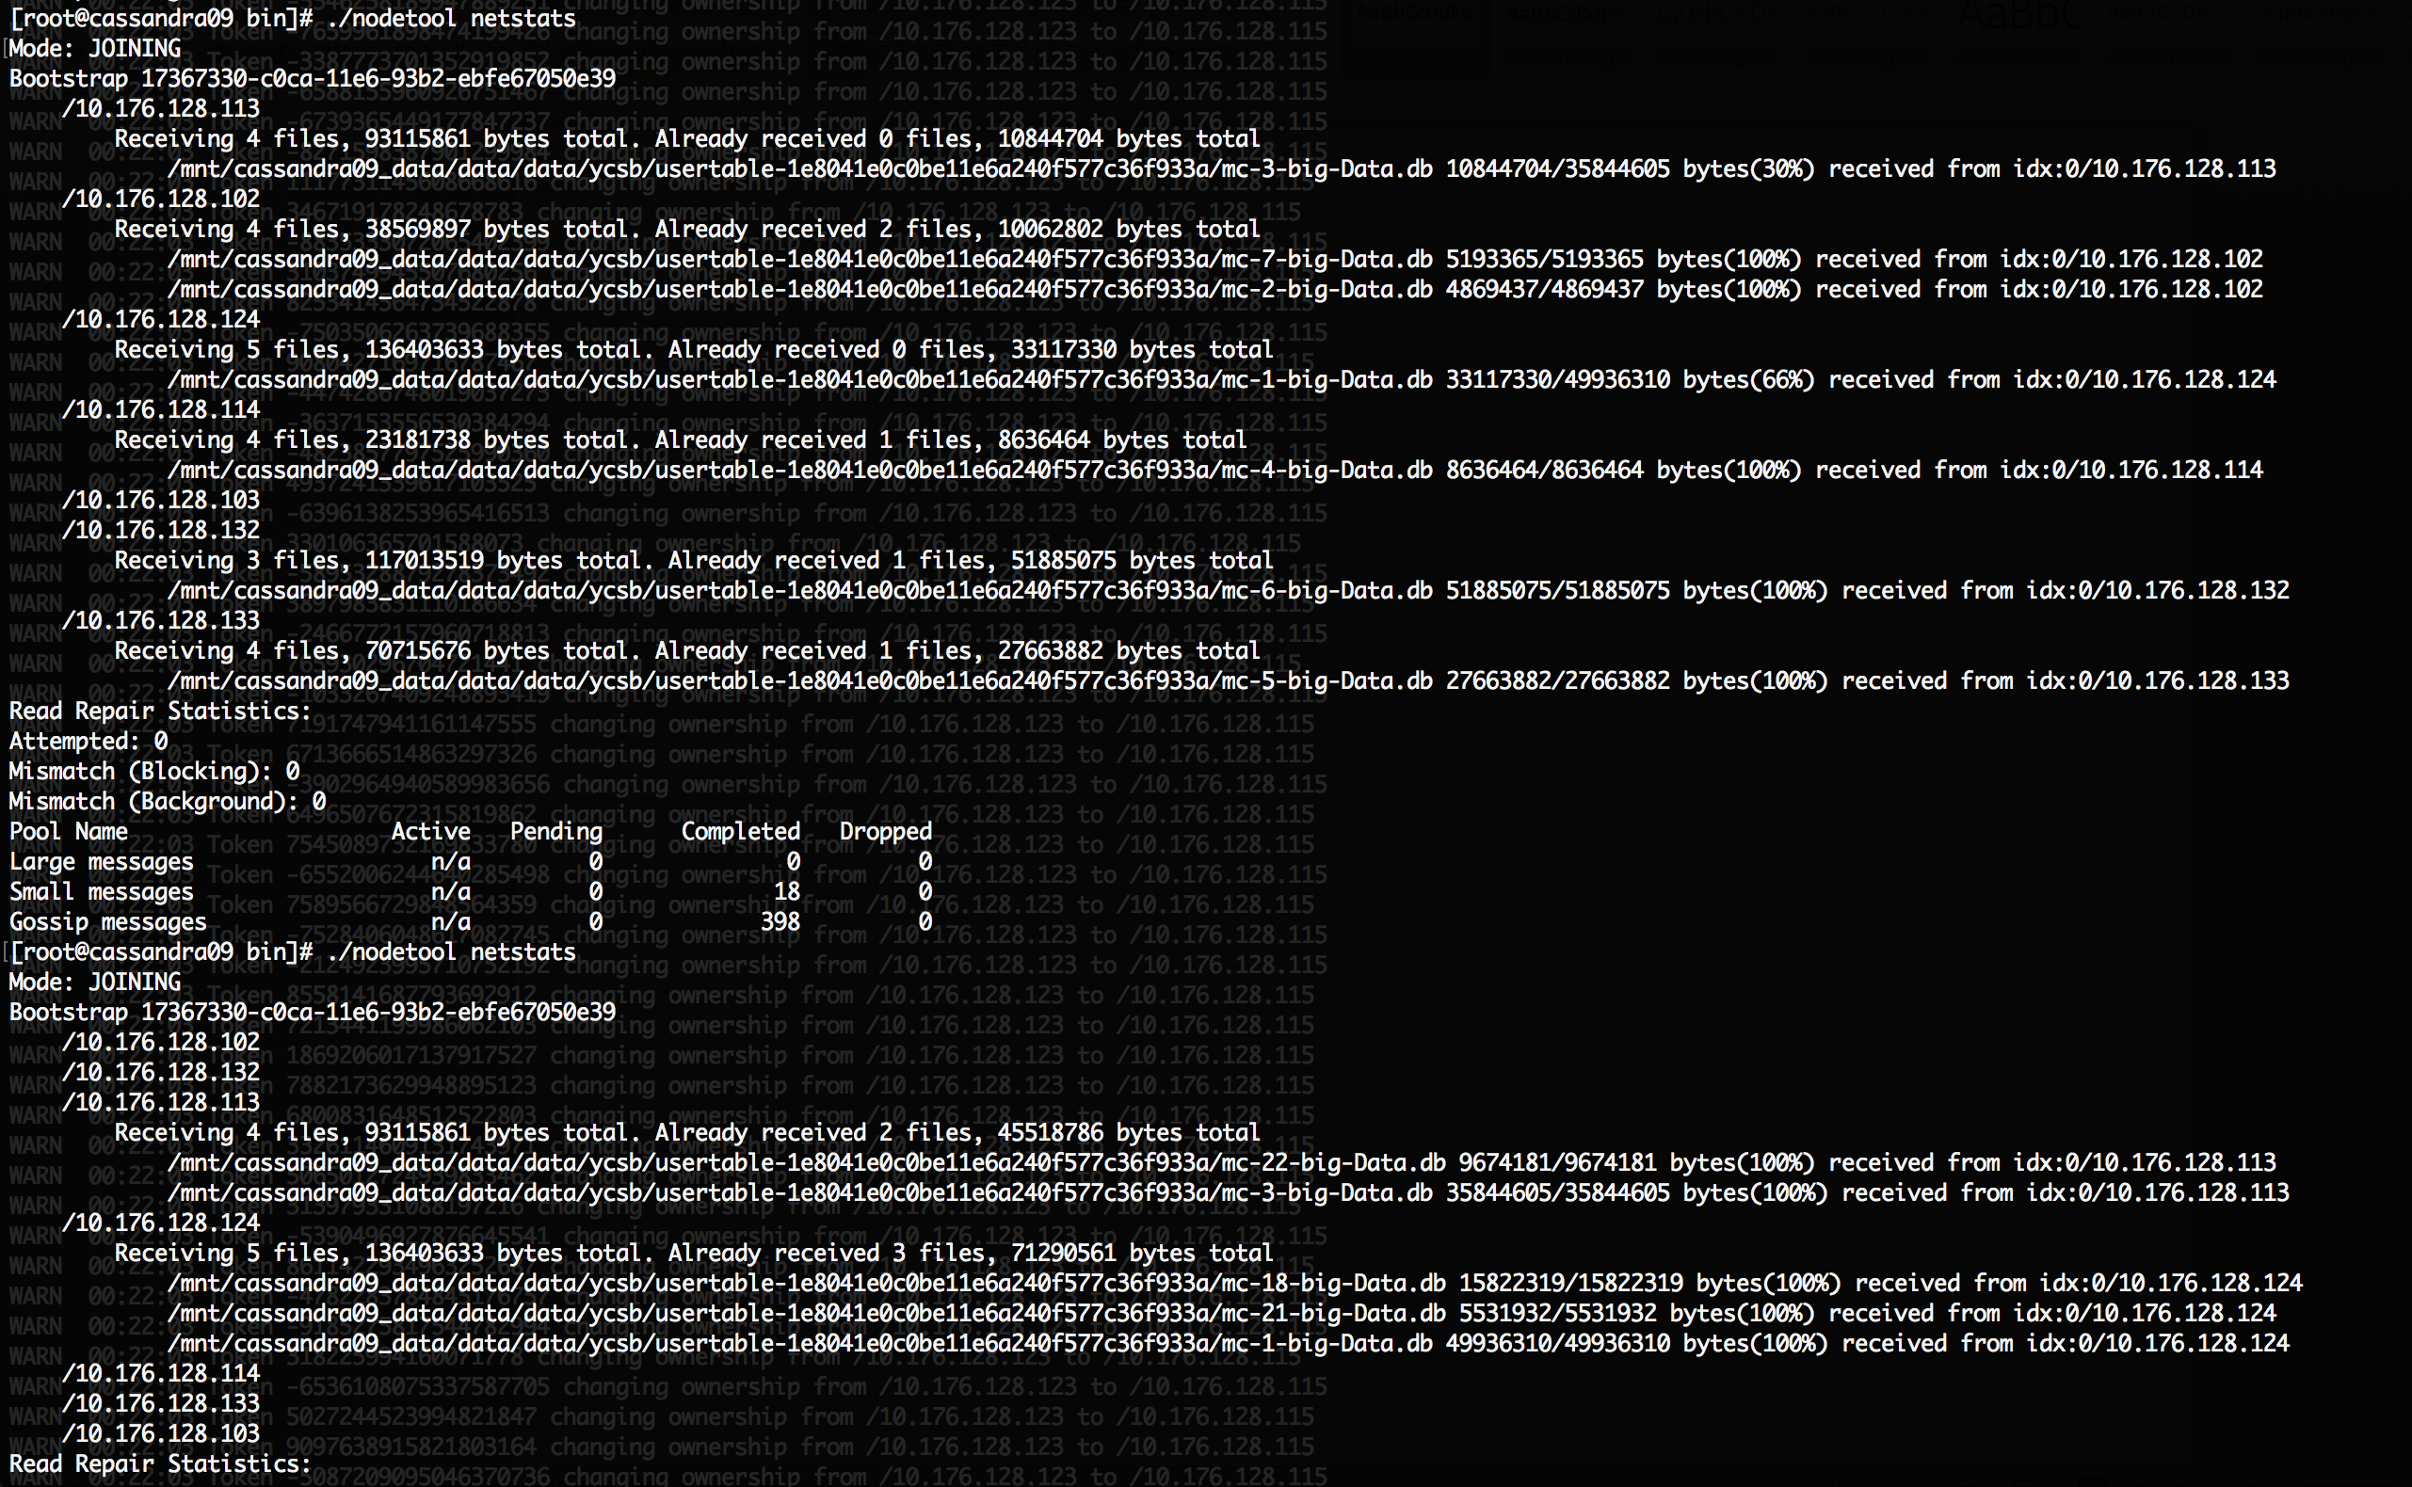

**Number of Messages used for replacement**

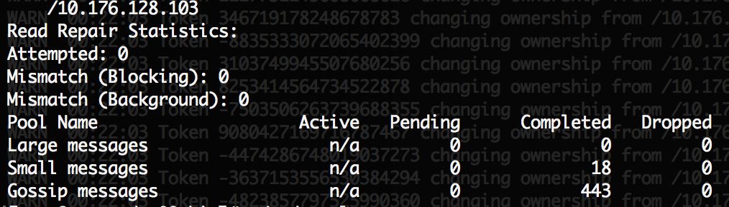

This replacement operation took around 4 minutes in total.

### Observation 2 – Performance Impact of Read Consistency Level

Cassandra offers different read consistency levels and we wanted to measure the performance impact of giving a higher consistency level during read.

In this experiment, we have measured performance of consistency level ONE vs ALL.

**ALL Consistency Level**

Returns the record after all replicas have responded. The read operation will fail if a replica does not respond.

**ONE Consistency Level**

Returns a response from the closest replica, as determined by the snitch. By default, a read repair runs in the background to make the other replicas consistent.

|  |  |  |
| --- | --- | --- |
| **Consistency Level** | **Throughput** | **Read Latency** |
| ONE | 10263.0417 | 3016.1465 |
| ALL | 8084.0090 | 3855.6759 |

We can observe as expected the consistency level of ONE has a higher throughput and a lower latency.

### Observation 3 – Hotspot Testing

The objective of this experiment is to create hotspots in the Cassandra cluster and see how the performance is affected.

To create hotspots we must make sure that all request are sent to a subset of nodes. To identify the keys present in every node we follow the following procedure:

1) From the cassandra bin directory run this command:

cd /root/dsc-cassandra-3.0.9/bin/

./nodetool flush -- ycsb usertable

2) The data will be flushed to disk from memtable.

3) Then navigate to the following directory:

cd /mnt/cassandra02_data/data/data/ycsb/usertable56b7e1a0a1db11e6b7e6b56bf1ab73db

4) A file named mc-1-big-Data.db should be present here.

5) Now navigate to the following folder: cd /root/dsc-cassandra-3.0.9/tools/bin

6) Run the following command:

./sstabledump -e /mnt/cassandra02_data/data/data/ycsb/usertable-56b7e1a0a1db11e6b7e6b56bf1ab73db/mc-1-big-Data.db > keys.txt

The file keys.txt will have all the files key owned by a node. Similarly, we can obtain keys for the other nodes.

Once the keys are obtained we can use a modified YCSB to send requests for only these subsets of keys. This would create a hotspot.

### Observation 4 - Cluster Behavior on killing a node while running YCSB workloada

While running workloada which consists of 50% reads and 50% updates we encountered the following issue when we bring a node down.

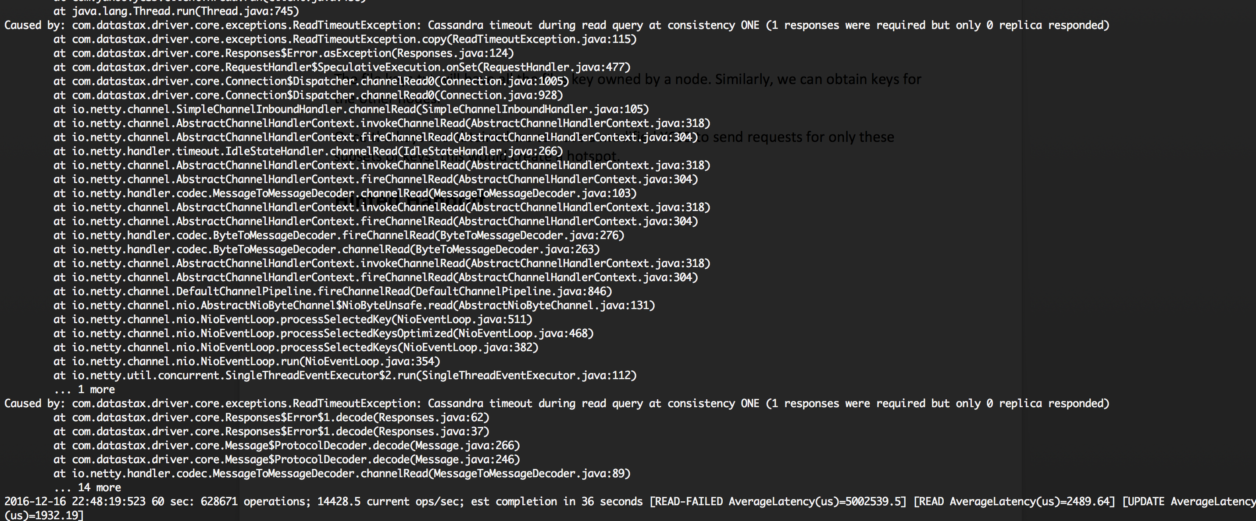

But running the same YCSB workload again didn’t give this issue. We are still considering this issue, but we found this interesting and wanted to document it.

### Observation 5 – Decommisioning a node in Cassandra

./nodetool decommission

On running the above command the node moves to LEAVING state.

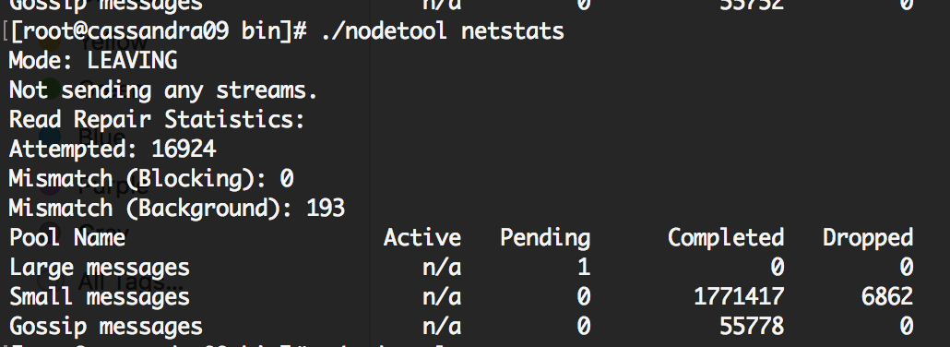

Below is a screenshot showing another node receiving file from the decommissioned node.

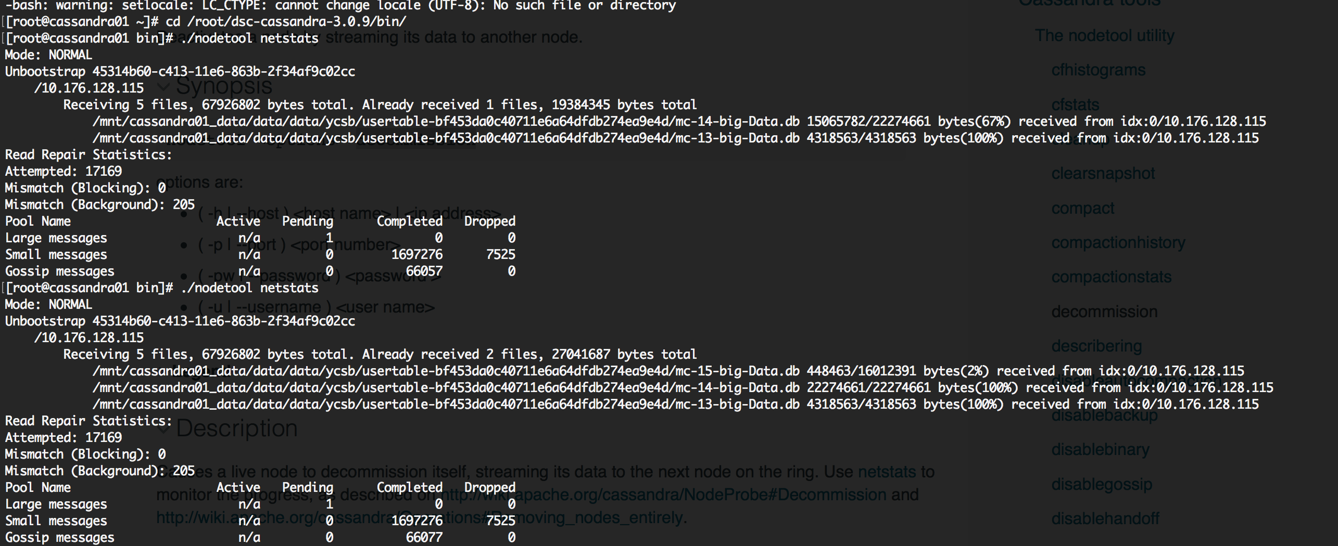

After its data has to streamed or offloaded to other nodes, it is moved to DECOMMISSIONED state.

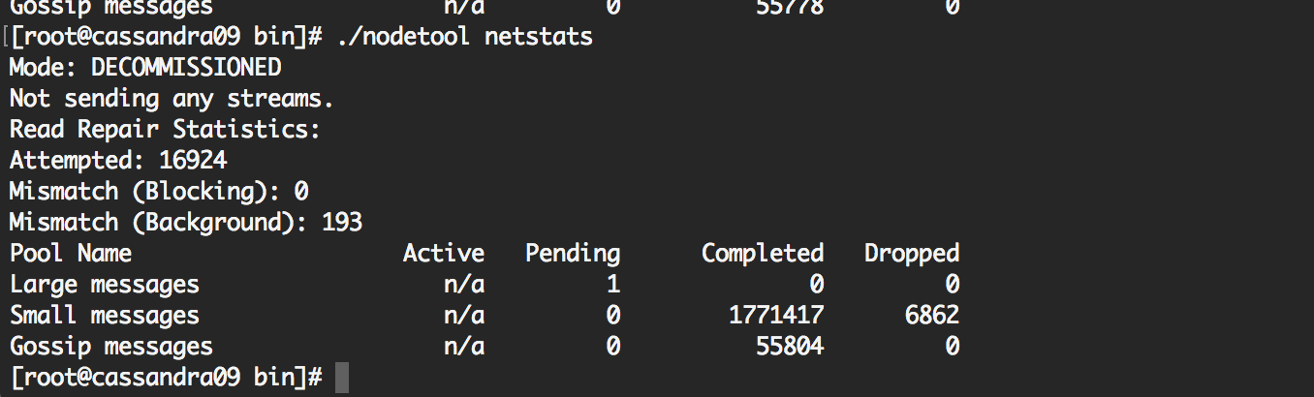

The updated nodetool status no longer shows the old node.

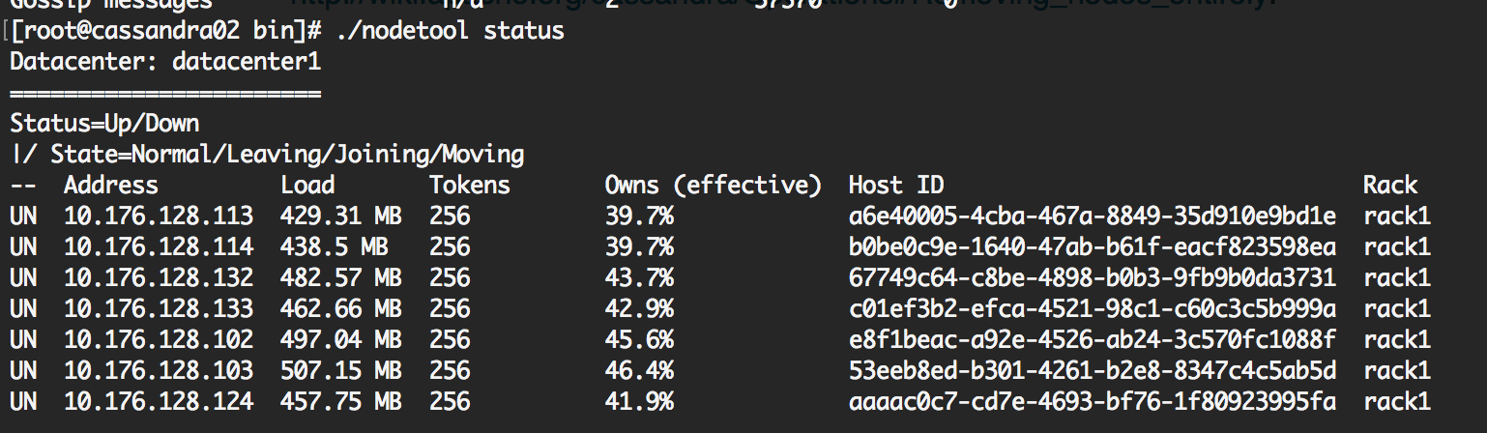

# YCSB Source Code Analysis and Creating unbalanced load.

## Code Flow

* The program starts executing from Client.java main method. It reads the command line arguments like thread count, workload to execute, load/run, and other parameters and sets property variables.
* Based on the thread count n, n number of ClientThreads’ are started and all are given the parameters.
* The individual threads sleep for a random amount of time to make sure that all client threads don’t hit the Database at the same time.
* While operation count is not 0 and operations completed is less than the requested number of operations in workload file, each thread calls the CoreWorkloads’ doTransaction() method.
* The doTransaction() method makes use of a DiscreteGenerator to generate the next type of operation. The operation could be a READ, UPDATE, INSERT, SCAN, READ-MODIFY-WRITE. DELETE is not supported in YCSB at the moment. The probability of the next operation is based on the proportion of that particular operation you have given in the workload file.

## Code Flow for Load

* For load operation, from the doTransaction() method, doTransactionInsert() will be called.
* The keynum for a new record insert is generated in the following way:
  + YCSB makes use of an AtomicInteger to generate keynum. The AtomicInteger counts up till the record count mentioned in the workload file. The number generated by the AtomicInteger is hashed and the has value is prefixed with ‘user’. This the record that is inserted into the database.
  + The values inserted by YCSB are not kept track as observed for code analysis. This understanding was cemented by a small experiment. The experiment is described below:
    - While loading data into YCSB, use record count as 100. Only 100 users will be inserted into the user table. The AtomicInteger will increment from 1 to 100. The number generated is hashed and prefixed with ‘user’ and inserted.
    - While reading giving record count as 1000. You will see READ-FAILED in the command line output. This shows that YCSB just uses the record count parameter in the workload file to generate keynums within this range and process queries. No Separate storage to keep track of keys previously inserted.

## Code Flow for Read

* In doTransactionRead(), nextkeynum() is called to randomly select a key value between 1 and record count in the workload file. Since there is not delete in YCSB, it is guaranteed that the key in this range will be present in the database since the same record count was used for load.
* This implementation of read is quite trivial and makes it very difficult to generate hotspots in the cluster with unbalanced workloads.
* We need to modify the doTransactionRead() function so that it can generate unbalanced workload.

## Creating unbalanced workloads for Cassandra using YCSB

**Tentative approach**

. /nodetool getendpoints ycsb usertable user5807057128595754517

10.176.128.123

10.176.128.114

10.176.128.113

The above commands lists’ which nodes in the ring own the user key. The above keyspace has a replication factor of 3.

One approach could be to get all the keys in the database from all the database. Pass each key to the above command and find out to which node it belongs. We need to keep replication factor as 1 in this case. If 3, then multiple nodes will be returned.

Choose to target one node and fetch all keys that belong to that node. Now modify the YCSB CoreWorkload’s dotransactionRead() method to query only for these keys. This will create hotspot in the cluster.

## Creating unbalanced workloads for Hbase using YCSB

Similar approach needs to be constructed for Hbase. Still working on it.

# Difficulties Faced

## Cassandra

* We were not sure of the value to be given for rpc_address and broadcast_rpc_address and we spent a sometime identifying the ideal configuration.
* We expanded the Cassandra VMs disk to 256GB using gparted instead of attaching a disk stored as an image in the host machine. The VMs qcow2 image increased a lot in size when we were testing for 1 million records or more. Had to correct this.
* We had initially given only 2 vCPUs and 2GB of RAM for the VMs. This was not sufficient and the performance was lacking. We then increased the configuration to 4 vCPU and 4GB of RAM. There was a considerable improvement in performance.
* Cassandra client is giving timeout error when querying large ranges or aggregate functions for a large dataset. Still need rectify this issue. But it’s not a problem. Just an observation. This behavior is justified in many occasions.

## Hbase

* Initially we had the datanodes and the regionservers in separate VMs, in some cases also in different host machines. This caused some overhead. After researching the web, we found that it’s better for the regionservers and datanodes to be on the same host machine.
* Had to choose between having a separate zookeeper VM instance or the implicit one with the master.
* We didn’t know that truncating a table in Hbase also removes the presplitting (n_splits = x) initially assigned. Write requests started going to only one regionserver and throughput was low. We identified this issue from the HBase master GUI running at port 60010. Using truncate_preserve resolved the issue and retained the pre-splitting.
* Had some issues running YCSB for Hbase from remote host. Not as straight forward as Cassandra where we mention the hosts as a parameter to the YCSB command. Required some analysis.
* Had to setup passwordless login for seamless startup and shutdown of Hbase and Hadoop.

## Bridged Network Setup

* Initially we were not able to ping the VMs using the Bridged Network. This was due to the fact that we had created the Bridge to use DHCP, but the VMs to have a static IP. We then changed the Bridge to a static IP and this resolved the issue. Had to refer a lot of material online to figure this out.

# Cassandra Architecture in brief:

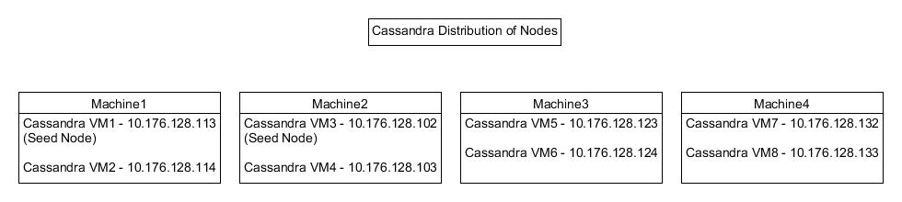

* Cassandra is designed to handle big data workloads across multiple nodes with no single point of failure. The architecture is based on the fact that system and hardware failures will occur.
* Cassandra addresses the problem of failures by employing a peer-to-peer distributed system across homogeneous nodes where data is distributed among all nodes in the cluster. Each node exchanges information across the cluster every second.
* A sequentially written commit log on each node captures write activity to ensure data durability.
* Data is then indexed and written to an in-memory structure, called a memtable, which resembles a write-back cache. Once the memory structure is full, the data is written to disk in an SSTable data file. All writes are automatically partitioned and replicated throughout the cluster. Using a process called compaction Cassandra periodically consolidates SSTables, discarding obsolete data.
* Cassandra is a row-oriented database. Cassandra's architecture allows any authorized user to connect to any node in any data center and access data using the CQL language. For ease of use, CQL uses a similar syntax to SQL. From the CQL perspective the database consists of tables.
* Typically, a cluster has one keyspace per application. Developers can access CQL through cqlsh utility.
* Client read or write requests can be sent to any node in the cluster. When a client connects to a node with a request, that node serves as the coordinator for that particular client operation. The coordinator acts as a proxy between the client application and the nodes that own the data being requested. The coordinator determines which nodes in the ring should get the request based on how the cluster is configured.

The “Cassandra.yaml” is the main configuration file for Cassandra.

Properties modified as part of Installation (General Properties):

* **cluster_name:**

The name of the cluster. This setting prevents nodes in one logical cluster from joining another. All nodes in a cluster must have the same value.

* **listen_address:**

Specified the IP address of the node. This helps the Cassandra nodes to communicate with each other. It can be set to localhost for a single node cluster. One should never specify 0.0.0.0

* **broadcast_address:**

Specified the IP address of the node.

* **rpc_address:**

Specified 0.0.0.0.

* **broadcast_rpc_address:**

Specified the IP address of the node. This needs to be set if rpc_address is set to 0.0.0.0.

**Default Directories:**

* **commitlog_directory:**

Set this to a directory externally mounted to the Virtual Machine.

* **data_file_directories:**

Set this to a directory externally mounted to the Virtual Machine.

* **saved_caches_directory:**

Set this to a directory externally mounted to the Virtual Machine.

* **hints_directory:**

Set this to a directory externally mounted to the Virtual Machine.

* **seed_provider:**

-seeds:

Two nodes are given as seeds. These nodes are used by ‘gossip’ for bootstrapping new nodes joining a cluster. When running multiple nodes, one must change the list from the default value. In multiple data-center clusters, the seed list should include at least one node from each data center (replication group). More than a single seed node per data center is recommended for fault tolerance. Otherwise, gossip has to communicate with another data center when bootstrapping a node. Making every node a seed node is not recommended because of increased maintenance and reduced gossip performance. Gossip optimization is not critical, but it is recommended to use a small seed list (approximately three nodes per data center).

Important properties whose value was set to the default:

* **endpoint_snitch :**

Default set to SimpleSnitch

* **partitioner:**

This property is set to default which is “org.apache.cassandra.dht.Murmur3Partitioner”. This uniformly distributes data across the cluster based on MurmurHash hash values. It is faster compared to RandomPartitioner which was the default before Cassandra 1.2.

* **num_tokens:**

Set this to 256. If not using, 1-token-per-node. If one does not want to use vnodes, can use initial_token property to set.

Once the cluster is set up, one can use the ‘nodetool’ utility provided by Cassandra to learn more about different stats as follows:

The nodetool utility is a command line interface for managing a cluster.

* **nodetool status:**

Provide information about the cluster, such as the state, load, and IDs.

Command can be written as follows:

./nodetool status

Following is what we see, once the cluster nodes are up and running.

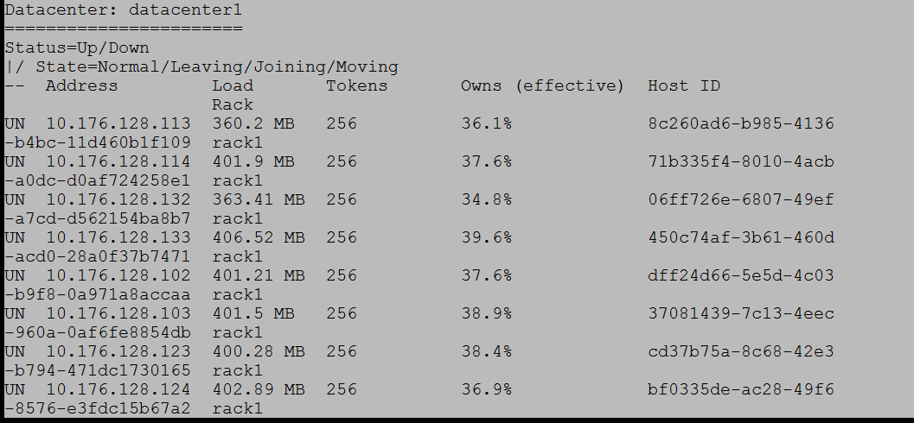

* **nodetool getendpoints:**

Provides the IP addresses or names of replicas that own the partition key.

This utility can be used to find the nodes that hold the replicas of a specific key say ‘user5807057128595754517’

The command can be written as follows:

./nodetool getendpoints ycsb usertable user5807057128595754517

Following is the output (3 replicas and the node they are assigned to):



* **nodetool ring:**

Provides node status and information about the ring. It is used to output all the tokens of a node.

The command can be written as follows:

./nodetool ring ycsb

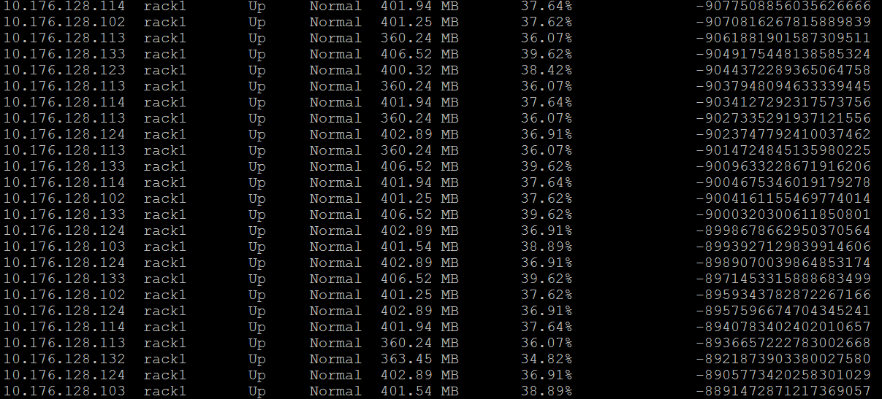

The total row count is 2048, which justifies 256 tokens per node.

256 * 8 = 2048.

* **nodetool describecluster:**

Provide the name, snitch, partitioner and schema version of a cluster

The command can be written as follows:

./nodetool describecluster

The output is as shown below:



* **nodetool describering:**

Provides the partition ranges of a keyspace.

The command can be written as follows:

./nodetool describering ycsb

The output is as shown below:



This is shown for all the partition ranges of a keyspace.

These and many more “nodetool” utilities help in managing the cluster.

# Hbase Architecture In Brief

**For Hbase we first set up the Hadoop platform:**

Configure Hadoop configuration files (core-site.xml, hdfs-site.xml, mapred-site.xml, yarn-site.xml). Replicate all the four files on all the 6 data nodes.

**hadoop-env.sh**

This file specifies environment variables that affect the JDK used by Hadoop Daemon (bin/hadoop). As the Hadoop framework is written in Java and uses Java Runtime environment, one of the important environment variables for Hadoop daemon is $JAVA_HOME in hadoop-env.sh. This variable directs Hadoop daemon to the Java path in the system.

**core-site.xml**

This file informs Hadoop daemon where name node runs in the cluster. It contains the configuration settings for Hadoop Core such as I/O settings that are common to HDFS and MapReduce. The file includes hostname and port on which name node daemon runs and listens.

**hdfs_site.xml**

This file contains the configuration settings for HDFS daemons; the Name Node, the Secondary Name Node, and the data nodes.

You can also configure hdfs-site.xml to specify default block replication and permission checking on HDFS. The actual number of replications can also be specified when the file is created. The default is used if replication is not specified in create time.

The value “true” for property ‘dfs.permissions’ enables permission checking in HDFS and the value “false” turns off the permission checking. Switching from one parameter value to the other does not change the mode, owner or group of files or directories.

**mapred-site.xml**

This file contains the configuration settings for Map Reduce daemons; the job tracker and the task-trackers. The mapred.job.tracker parameter is a hostname (or IP address) and port pair on which the Job Tracker listens for RPC communication. This parameter specifies the location of the Job Tracker to Task Trackers and Map Reduce clients.

**yarn-site.xml**

This file contains the configuration settings for Resource Manager and Node Manager.

The configuration files should be replicated in the data nodes. Use ’scp’ command in the name node to copy the core-site.xml, hdfs-site.xml, mapred-site.xml and yarn-site.xml onto the data nodes.

**Edit Masters and Slaves file on each node.**

The ‘Masters’ file on the Master node contains the Hostname and IP Address of Secondary name node server. The ‘Masters’ file on the Slave Node is blank.

The ‘Slaves’ file on the Master node contains a list of hosts that run data node and node manager. The ‘Slaves’ file on the slave node contains its own IP address.

**Format Hadoop name node and start all Hadoop services.**

After formatting the Name Node, we can start the Hadoop services. ‘start–dfs.sh is the command to start the Name Node and Data Node. ‘start-yarn.sh is the command to start the Resource Manager and Node Manager.

The multi-node cluster is now setup. By opening the browser and entering the IP of the Name node, the setup of the multi-node cluster can be seen.

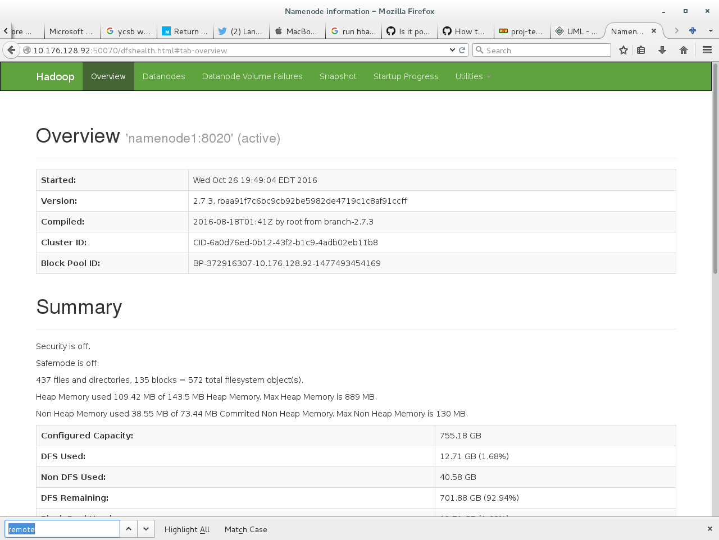

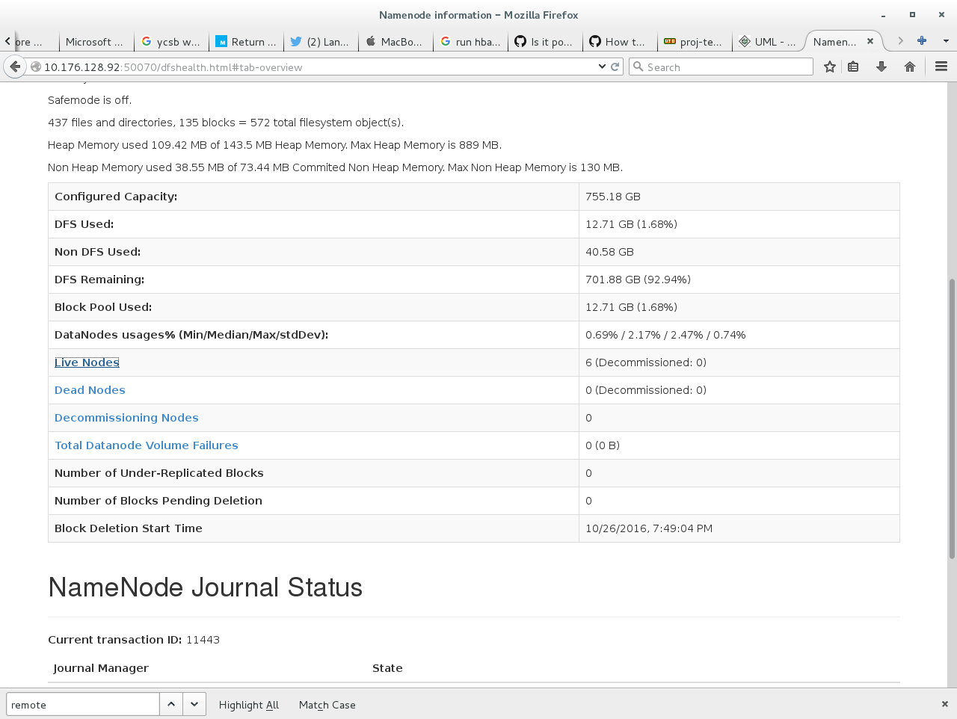

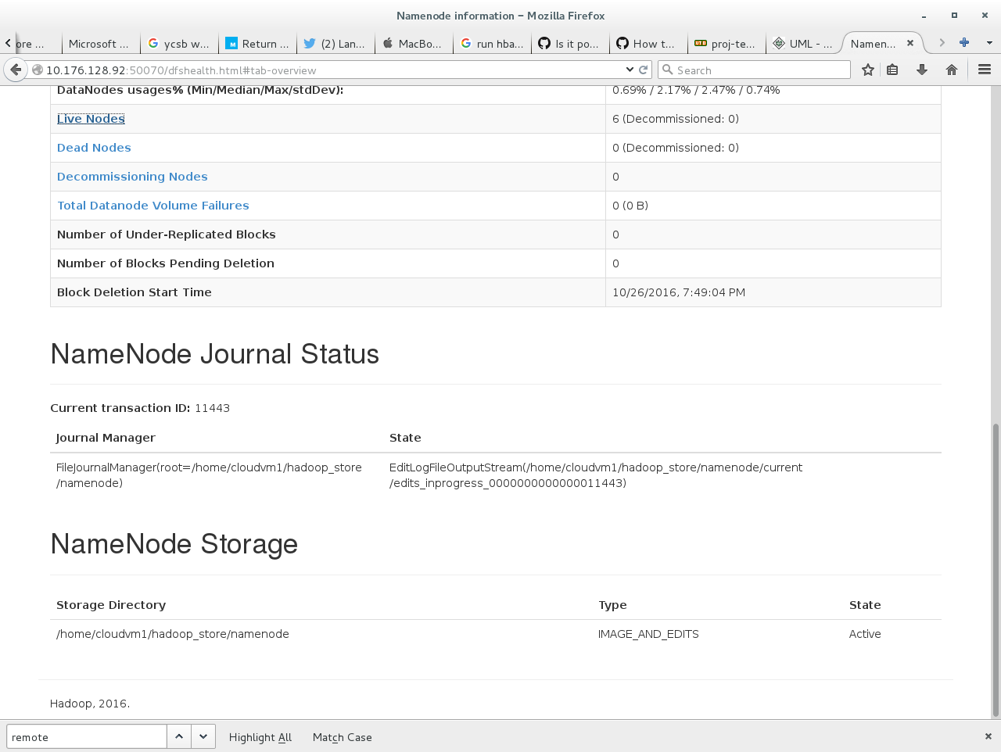

**HBASE**

Edit the hbase-env.sh to update JAVA_HOME variables on the name node and data nodes.

**hbase-site.xml**

Edit the hbase-site.xml on the master server node to contain the IP address of the Master and zookeeper.

Edit the client node servers and include the IP address of the name node and make the hbase cluster distributed variable to true.

**Regionservers file**

Edit regionservers file to include the host names of the master and client node servers.

Start the HBase cluster on the master server node with start_hbase.sh command.

After starting Hbase you access the web page using master server node IP and port ‘60010’.

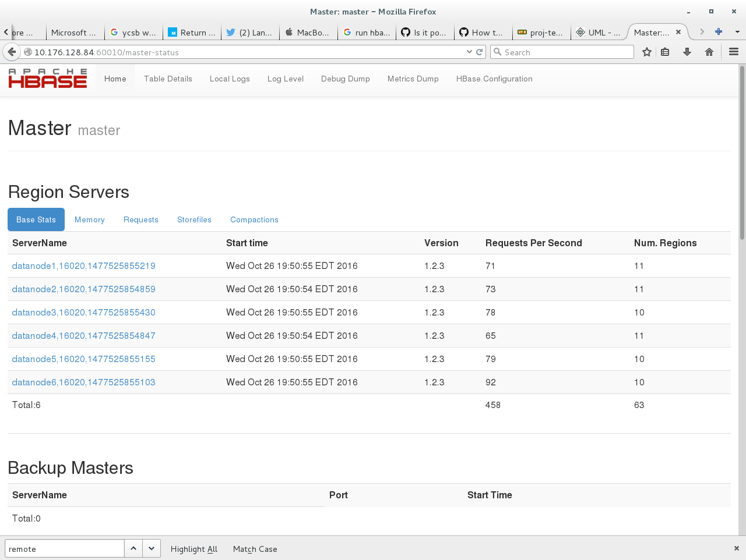

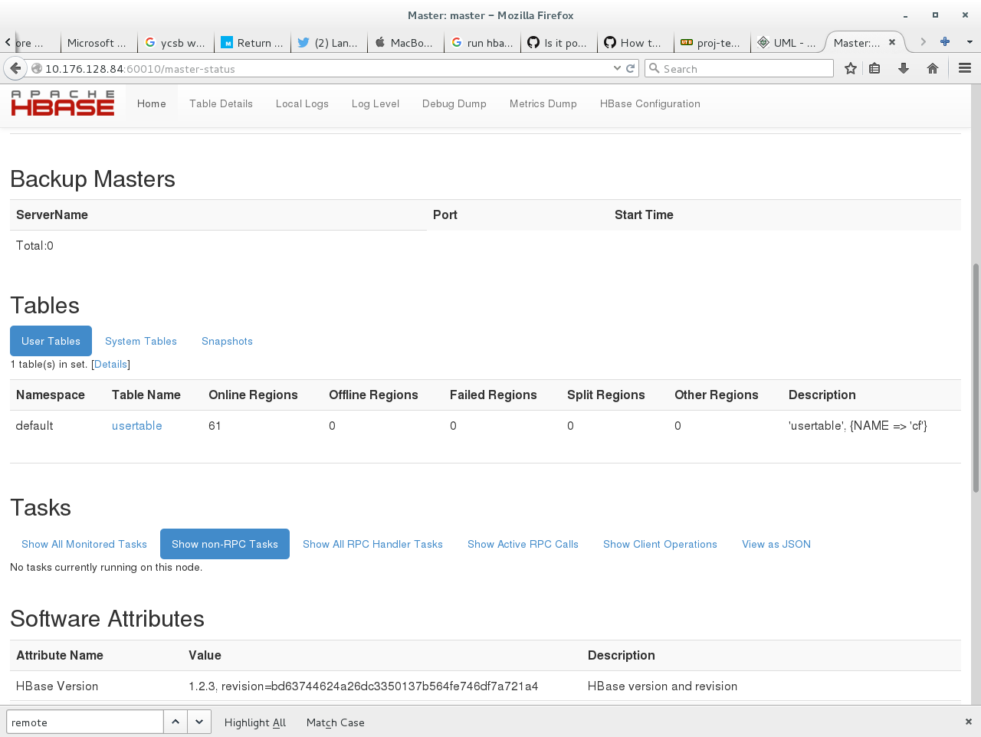

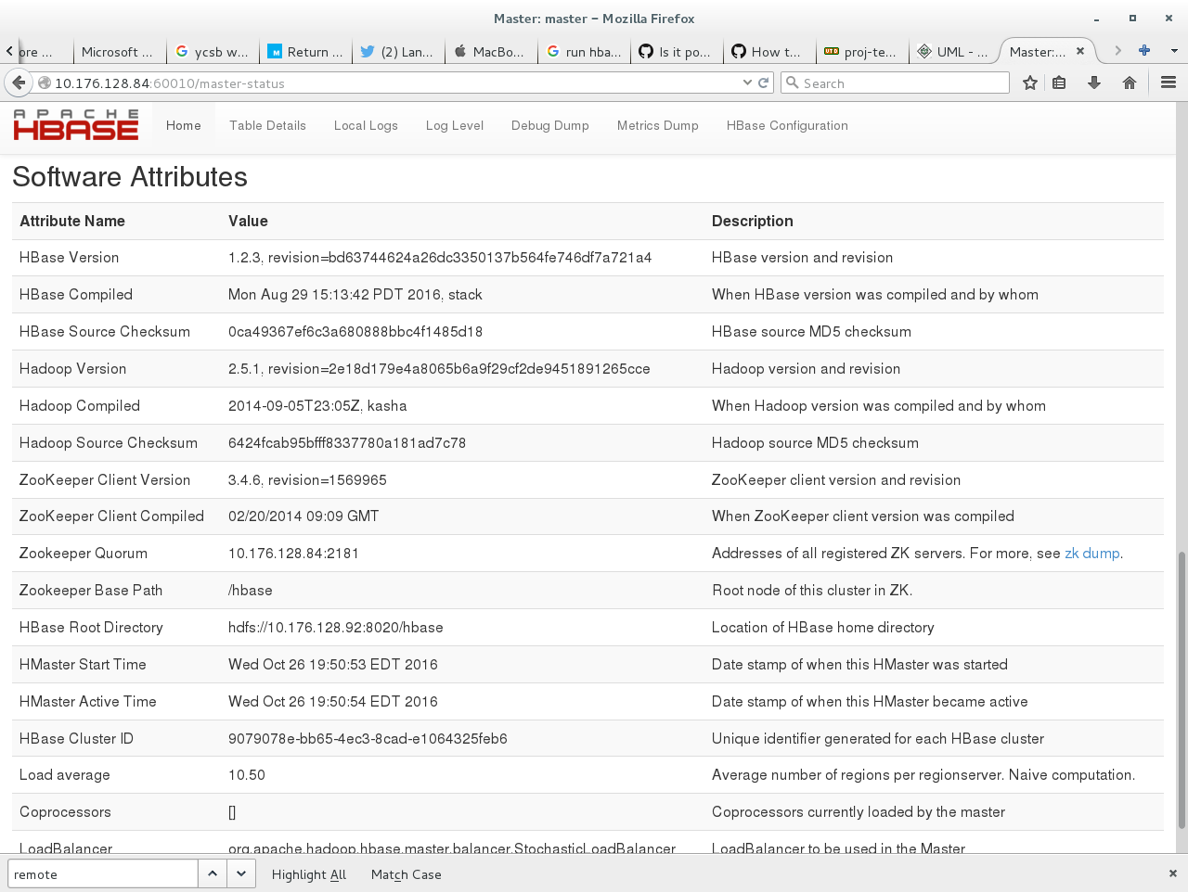

Now we have one master server and other region servers setup. Below is the command to run the workload on YCSB for Hbase.

# Redis – YCSB code modifications done to test cluster

YCSB by default does not support Redis is cluster mode. Therefore, benchmarking Redis using YCSB is not straightforward.

Some files and Maven dependencies must be modified and recompiled for it to work in cluster mode.

**RedisClient.java**

RedisClient.java located at $YCSB_HOME/ redis/src/main/java/com/yahoo/ycsb/db needs to be modified.

//private Jedis jedis;

private JedisCluster jedis;

Jedis needs to be replaced with JedisCluster. This will make YCSB support redis in cluster mode.

Also add the following lines:

jedisClusterNodes.add(new HostAndPort("10.176.128.141", port));

jedisClusterNodes.add(new HostAndPort("10.176.128.142", port));

jedisClusterNodes.add(new HostAndPort("10.176.128.143", port));

jedisClusterNodes.add(new HostAndPort("10.176.128.144", port));

jedisClusterNodes.add(new HostAndPort("10.176.128.81", port));

jedisClusterNodes.add(new HostAndPort("10.176.128.82", port));

jedisClusterNodes.add(new HostAndPort("10.176.128.83", port));

Initially we had only one node and all requests were going to that node and getting redirected to other nodes. Hence our Redis cluster performance was bad. Now we have rectified this and all the above lines and our Redis Cluster is performing better that Cassandra and Hbase.

**pom.xml**

Also $YCSB_HOME/pom.xml needs to be modified. The redis.version tag need to be modified as show below:

<redis.version>2.9.0</redis.version>

Now when we build with maven it will download the latest jar that has JedisCluster as a part of it.

With these modification YCSB is ready to support Redis in cluster mode.

### Redis Cluster Creation

Once we have Redis installed on all the VMs we can setup a Redis Cluster by executing the following command:

./redis-trib.rb create --replicas 1 10.176.128.141:6379 10.176.128.142:6379 10.176.128.143:6379 10.176.128.144:6379 10.176.128.81:6379 10.176.128.82:6379

The replicas option in this command creates one slave for every master as show in the screenshot below



To create all nodes as master and none as slaves remove the replicas option.



### Redis Node Addition

To add a node to the existing cluster execute the following command.

./redis-trib.rb add-node 10.176.128.143:6379 10.176.128.141:6379

The first argument is the new node to be added and the second argument is a reference to an existing node in the cluster.

Redis allows us to add a new node as a master or a slave to an existing master. This can also be specified in the command above if needed.

### Redis Node Deletion

Redis Node deletion can be handled in 2 ways

1. **Resharding (Load Balancing)**

To delete a node in Redis we will first have to reshard all the keys it owns to other masters to avoid complications. This is done with the below command:

./redis-trib.rb reshard --from 07845255b5a4d786610ca1b8a391a69785376900 --to 264fd34d47dd9eada029f407cf8eddace7cf91ce --slots port --yes 10.176.128.141:6379

This command will ask how many slots we wish to move. We can choose appropriately. If we want to delete the node we reshard all of it. This is also a way of load balancing.

Then execute the following command to delete the node from the cluster:

./redis-trib del-node 10.176.128.141:6379 '07845255b5a4d786610ca1b8a391a69785376900'

1. **Manual Slave Failover**

We can configure sentinals in redis which automatically failover slaves once a master is dead. Sentinals participate in a voting process if the master has more than one slave to elect the one with the latest information.

# Redis – DHT Implementation

## Basic DHT Data Structure

DHT data structure stores the HASHSLOTS served by the nodes of the cluster. It is implemented as a ConcurrentSkipListMap of key type Integer (slot number) and the value is Node object (node responsible for the given slot).

## Architecture in Brief

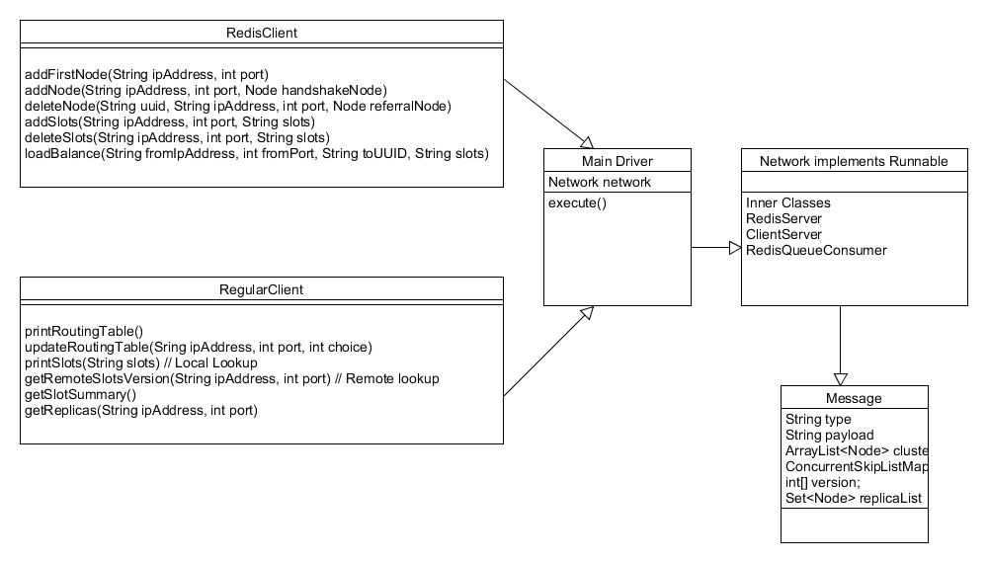

## Implementation Details

Redis Client (Control Client) –

* addFirstNode

This method adds the very first node to the cluster.

* addNode

This method adds the subsequent nodes to the cluster with the help of an existing node. The existing node introduces the new node to all the other nodes of the cluster.

* deleteNode

This method deletes the requested node with the request being made to an existing node in the cluster. It is a 2-step process for delete – Kill and Update.

* addSlots

This method is used to assign the slots to a specific node of the cluster. It prohibits assigning slots that are already being served by other active nodes of the cluster.

* deleteSlots

This method is used to unassign the slots which are being served by some node of the cluster.

* loadBalance

This method is used to perform load balancing. Slots that are currently being served by a node can be off loaded to the other node in the cluster.

Regular Client

* printRoutingTable

Prints the routing table locally

* updateRoutingTable

Gets the routing table information remotely and updates the local copy.

* printSlots

This is a local lookup. Prints the slot information that is in local cache.

* getRemoteSlotsVersion

This is a remote lookup. This is performed only if the current max version of the local copy is lagging behind or if the last updated id of the table has been modified. In other scenarios, local copy is only printed. So it’s a three step process read request followed by a lookup request followed by a table-update request if required .

* getReplicas

Prints the slave nodes of the given master node.

MainDriver

The program that executes on all nodes of the cluster. It interacts with the Network class.

Network

The class that handles all the message passing and handling the incoming messages.

Message

It is a POJO class that comprises of attributes which comprise a Message that is exchanged between the nodes, and between clients and the node.

# Workload Distribution:

|  |  |  |
| --- | --- | --- |
| Sr. No | Tasks | Done By |
| 1. | Centos Installation on all machines | Chandani/Priyanka/ Raveena/Roshan |
| 2. | KVM Installation on all machines | Chandani/Priyanka/ Raveena/Roshan |
| 3. | Cassandra Installation | Chandani |
| 4. | Cassandra Clone VMs | Raveena, Priyanka |
| 5. | Hadoop Installation | Priyanka |
| 6. | Data nodes – Hadoop Clone VMs | Roshan |
| 7. | HBase Installation | Roshan |
| 8. | Region Servers – Clone VMs | Chandani, Roshan |
| 9. | YCSB Installation | Raveena |
| 10. | Running Tests on YCSB | Raveena, Priyanka |
| 11. | Performance Analysis and Graph Plots | Chandani/Priyanka/ Raveena/Roshan |
| 12. | YCSB Code Analysis | Roshan |
| 13. | Attach external disk to Hbase VMs | Roshan |
| 14. | Attach external disk to Cassandra VMs | Chandani |
| 15. | YCSB Redis Cluster Changes | Chandani |
| 16. | Cloning Script | Chandani/Priyanka |
| 17. | Partitioning Script | Roshan/Raveena |
| 18. | Redis DHT Control Client | Priyanka |
| 19. | Redis DHT Regular Client | Raveena |
| 20. | Redis DHT Network | Chandani/Roshan |
| 21. | Cassandra Experimental Analysis | Chandani/Priyanka |
| 22. | Hbase Experimental Analysis | Roshan/Raveena |
| 23. | Redis Experimental Analysis | Chandani/Priyanka/ Raveena/Roshan |
| 24. | Report Writing | Chandani/Priyanka/ Raveena/Roshan |

# One Drive Link:

# <https://cometmail-my.sharepoint.com/personal/cxm152930_utdallas_edu/_layouts/15/guestaccess.aspx?guestaccesstoken=zMO1IXf%2fKuhWlw1qxVF9dsgwSdw9maT90uq4PHwsJEQ%3d&folderid=2_1382254ec285646bfb85c1853298da1f6&rev=1>

# References:

* <http://www.howtogeek.com/howto/40702/how-to-manage-and-use-lvm-logical-volume-management-in-ubuntu/>
* <https://en.wikibooks.org/wiki/QEMU/Images#Creating_an_image>
* <https://raymii.org/s/tutorials/KVM_add_disk_image_or_swap_image_to_virtual_machine_with_virsh.html>
* <https://access.redhat.com/documentation/en-US/Red_Hat_Enterprise_Linux/6/html/Virtualization_Administration_Guide/sect-Virtualization-Virtualized_block_devices-Adding_storage_devices_to_guests.html>
* <http://dl.fedoraproject.org/pub/epel/7/x86_64/e/epel-release-7-8.noarch.rpm>
* <https://www.digitalocean.com/community/tutorials/how-to-configure-a-redis-cluster-on-centos-7>
* Yahoo! Cloud Serving Benchmarkgithub.com <https://github.com/brianfrankcooper/YCSB/wiki/Core-Workloads>
* <https://www.cs.duke.edu/courses/fall13/compsci590.4/838-CloudPapers/ycsb.pdf>
* <http://www.datastax.com/wp-content/themes/datastax-2014-08/files/NoSQL_Benchmarks_EndPoint.pdf>